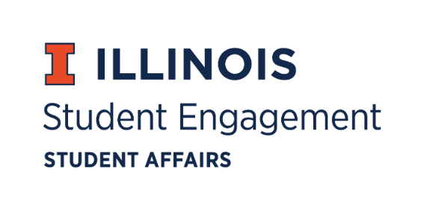
Student Organization
Resource Fee
SORF Meeting
Monday, May 1, 2023, at 5:30PM
Student Org Complex
Call to Order:
Faraz Khan calls meeting to order at 5:32pm. Faraz Khan calls recess at 5:52pm. Faraz Khan calls meeting back to order at 5:59pm.

Roll Call:
Present:
- Faraz Khan, Chairperson
- Chris Gasche, Vice-Chairperson
- Dipankar Yettapu, Undergraduate Board Member
- Fawwaz Ahmed, Undergraduate Board Member
- Jimmy Ewers, Undergraduate Board Member
- Alfonso Munaco, Undergraduate Board Member (Dipankar Yettapu proxy)
- Amani Laliwala, Undergraduate Board Member
- Pragati Salunke, Undergraduate Board Member
- Arianna Agramonte Holterman, Faculty/Staff Board Member
- Stephanie Cardoza-Cruz, Faculty/Staff Board Member (Joined at 5:40 PM)
- Nick Fink, SORF Advisor (non-voting member)
- Christina Fraser, SORF Secretary (non-voting member)
Absent:
- Pablo Quispe, SORF Treasurer
- Myles Washington, Undergraduate Board Member
Old Business:
New Business:
05/01/23 Agenda:
- Chairperson’s Comments
- SORF Secretary Raise
- Appointment of returning SORF board members
- Election of new SORF board members
Chairperson’s Comments:
- Faraz thanks incoming board members for joining us and thanks exiting board members for all the great work they’ve done this past year.
SORF Secretary Raise:
- Pragati Salunke motions to increase the SORF Secretary’s wage from $13.50 per hour to $16.00 per hour for the 2023-2024 academic year. Amani Laliwala seconds. Vote of 9-0-0
Appointment of 2023-2024 SORF board members:
- Faraz Khan, Dipankar Yettapu, and Amani Laliwala are sworn in by completing the SORF Oath of Office.
- Arianna Agramonte Holterman motions to approve new SORF board members. Amani Laliwala seconds. Vote of 4-0-0
- New SORF board members:
  - Hayley Hoppock, Undergraduate Board Member
  - Kate Suchodolski, Graduate Board Member
  - Matthew Pruyn, Undergraduate Board Member
  - David Bein, Graduate Board Member
  - Destiny Gallegos, Undergraduate Board Member
  - Anika Chakraborti, Undergraduate Board Member
  - Troy Kowalski, Undergraduate Board Member
Nomination and Election of Chairperson:
- Troy Kowalski nominates Amani Laliwala for SORF Chairperson. Amani Laliwala accepts nomination. Vote of 10-0-0
Nomination and Election of Vice Chairperson:
- Faraz Khan nominates Dipankar Yettapu for SORF Vice Chairperson. Dipankar Yettapu accepts nomination. Vote of 10-0-0
Nomination and Election of Treasurer:
- Faraz Khan nominates Troy Kowalski for SORF Treasurer. Troy Kowalski accepts. Vote of 10-0-0

For the Good of the Order:
Adjournment:
Amani Laliwala adjourns meeting at 6:13pm.

