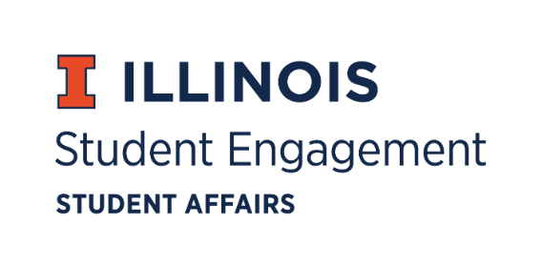
Student Organization
Resource Fee
SORF Meeting
Monday, November 7, 2022
Microsoft Teams Poll
Roll Call:
Present:
- Faraz Khan, Chairperson
- Chris Gasche, Vice-Chairperson
- Dipankar Yettapu, Undergraduate Board Member
- Fawwaz Ahmed, Undergraduate Board Member
- Jimmy Ewers, Undergraduate Board Member
- Alfonso Munaco, Undergraduate Board Member
- Myles Washington, Undergraduate Board Member
- Amani Laliwala, Undergraduate Board Member
- Pragati Salunke, Undergraduate Board Member
- Pablo Quispe, Undergraduate Board Member
- Stephanie Cardoza-Cruz, Faculty/Staff Board Member
- Arianna Agramonte Holterman, Faculty/Staff Board Member
- Brian Farber, Faculty/Staff Board Member
- Nick Fink, SORF Advisor (non-voting member)
- Christina Fraser, SORF Secretary (non-voting member)

Old Business:

Contingency Funding Application Review:

App Number | Funding Type | RSO Name | Amount Requested | Amount Allocated | Vote
166639 | Contingency | Illini Ridgebacks Quidditch Team | $1,000.00 | $1,000.00 | 7-1-3
170974 | Contingency | Illini Women's Soccer Club | $999.99 | $999.99 | 7-0-4

- App No. 166639- Illini Ridgebacks Quidditch Team
  - Description: The RSO unexpectedly received a bid to go to the regionals and would not be able to receive funding in any application period due to the timing of finding out. They are requesting funding for the tournament which includes hotel prices, for twenty members which is being hosted at South Bend Indiana to get a bid for nationals
  - Funding type: Contingency
  - Amount Requested: $1,000.00
  - Amount Allocated: $1,000.00
  - Meeting notes: Vote of 7-1-3 to fund at standard.
- App No. 170974- Illini Women’s Soccer Club
  - Description: A team unexpectedly dropped out which led to the RSO being invited to the Nationals. They would not qualify for funding under regular application periods due to the timing of this occurring. They are requesting an allocation for the registration fee for the NIRSA National Soccer Tournament 2022 which will be held in Alabama.
  - Funding type: Contingency
  - Amount Requested: $999.99
  - Amount Allocated: $999.99
  - Meeting notes: Vote of 7-1-3 to fund at standard.

