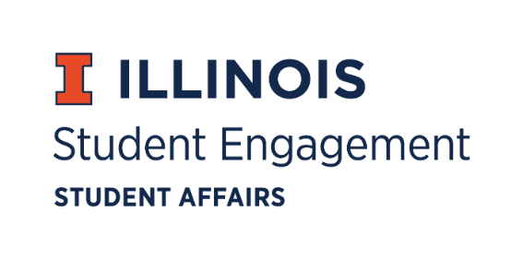
Student Organization
Resource Fee
SORF Meeting
Tuesday, October 18, 2022, at 8:00PM
Student Org Complex
Call to Order:
Meeting called to order at 8:05pm.

Roll Call:
Present:
- Faraz Khan, Chairperson
- Chris Gasche, Vice-Chairperson
- Dipankar Yettapu, Undergraduate Board Member
- Fawwaz Ahmed, Undergraduate Board Member
- Jimmy Ewers, Undergraduate Board Member
- Alfonso Munaco, Undergraduate Board Member
- Myles Washington, Undergraduate Board Member
- Amani Laliwala, Undergraduate Board Member (left meeting at 9:30pm)
- Pragati Salunke, Undergraduate Board Member
- Stephanie Cardoza-Cruz, Faculty/Staff Board Member
- Arianna Agramonte Holterman, Faculty/Staff Board Member
- Nick Fink, SORF Advisor (non-voting member)
- Christina Fraser, SORF Secretary (non-voting member)
Absent:
- Pablo Quispe, Undergraduate Board Member
- Brian Farber, Faculty/Staff Board Member

Old Business:
New Business:
10/18/22 Agenda:
- Chairperson’s Comments
- Appointment of new SORF Board Member
- Proposed appeals process
- Removal of Large-Scale Programming from standards
- Removing Projects Funding from standards
- Revising Programs Funding Criteria
- Revising RSO Maximum Allocations
- Implementing Mandatory SORF Workshop
- Revising Expense Report Deadline
Chairperson’s Comments:
- Chairperson Khan explains the addition of the SORF Operational Board Meetings.
- Chairperson Khan asks the board on how to use the official SORF Instagram to increase transparency and communication.
- Chairperson Khan takes board members’ opinions on member merchandise.
Appointment of New SORF Board Member:
- Chris Gasche motions to confirm Pragati Salunke as a new SORF Board Member. Alfonso Munaco seconds. Vote of 9-0-0.
Proposed Appeals Process:
- Proposed creation of an Appeals Form that includes general information about RSO and clearly outlines what is not grounds for an appeal. RSO may appeal up to Dr. Jim Hintz.
- Chris Gasche motions to approve the new Appeals Process. Myles Washington seconds. Vote of 10-0-0.
Removal of Large Scale Programming:
- Dipankar Yettapu motions to approve removing Large Scale Programming from the SORF standards. Myles Washington seconds. Vote of 10-0-0.
Revising Programs Funding Criteria:
- Proposed changing Programs Funding criteria from “Free for all attendees” to “free for UIUC Students”. Tied to this, we have defined UIUC student as someone who is currently enrolled at the University of Illinois Urbana-Champaign. We will be adding a question to Programs applications as follows: “What estimated percentage of attendees are expected to be UIUC Students?” This question will be used by SORF to determine if funding for an event is going to have substantial impact to the Illinois Campus Community, or if the event is designed to support other individuals or guests.
- Myles Washington motions to change Programs Funding Criteria. Chris Gasche seconds. Vote of 10-0-0.
Implementing Mandatory SORF Workshop:
- Myles Washington motions to implement mandatory SORF workshop requirement to general standard 9. Chris Gasche seconds. Vote of 10-0-0.
Revising Expense Report Deadline:
- Dipankar Yettapu motion to make deadline for Expense Report or Forfeiture Report 21 days after event. Myles Washington seconds. Vote of 10-0-0.
Removal of Projects Funding:
- Myles Washington motions to remove Projects Funding from SORF standards. Fawwaz Ahmed seconds. Vote of 2-5-3. Motion failed because the board felt as though getting rid of projects funding would negatively affect many RSOs on-campus
- Myles Washington motions to move to end of agenda. Chris Gasche seconds. Vote of 10-0-0.
- Myles Washington motions to change the language of Project Funding Standards section 5 and 6 to a maximum allocation of $5,000 per RSO per academic year to be able to accommodate for RSOs needing projects funding while being cognizant of SORF budget constraints. Chris Gasche seconds. Vote of 9-0-1.
Revising RSO Maximum Allocations:
- Chairperson Khan proposes to increase the max allocation per RSO per academic year from $10,000 to $12,000 in order to allow RSOs to be able to hold larger programs in absence of large-scale programming.
- Chris Gasche motions to move discussion to end of the meeting. Myles Washington seconds. Vote of 10-0-0.
- Myles Washington motions to deny increasing max allocation per RSO from $10,000 to $12,000. Alfonso Munaco seconds. Vote of 9-0-1.

For the good of the order:
Adjournment:
Meeting adjourned at 9:38pm.

