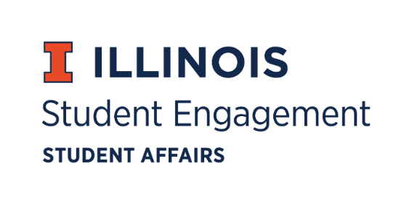
Student Organization
Resource Fee
SORF Meeting
Tuesday, April 12, 2022
Microsoft Teams
Roll Call:
Present:
- Michael Isaacson, Chairperson
- Alex Wang, Vice-Chairperson
- Umar Ahmed, SORF Treasurer
- Jimmy Song, Undergraduate Board Member
- Inaaz Mirza, Undergraduate Board Member
- Ashley Winters, Undergraduate Board Member
- Nico Perez, Undergraduate Board Member
- Damian Chavez, Undergraduate Board Member
- Brian Farber, Faculty/Staff Board Member
- Stephanie Cardoza-Cruz, Faculty/Staff Board Member
- Nick Fink, SORF Advisor (non-voting member)
- Christina Fraser, SORF Secretary (non-voting member)
- Sheri Idris, SORF Financial Secretary (non-voting member)
Absent:

Old Business:

Application Review for Tabled Spring Programs & Projects Funding Period 3, 3/10/22- 5/31/2022:
App Number | Funding Type | RSO Name | Amount Requested | Amount Allocated | Vote
145710 | Programs | Organic Oneness at UIUC | $5,900.00 | $3,250.00 | 8-0-2
145689 | Programs | Illinois Student Government | $4,506.00 | $0.00 | 7-0-3

- App No. 145710- Organic Oneness at UIUC
- Description: Weeklong project is to bring students and community members together in unity to do service, build relationships, share joy, and connect with each other. Line item 2 (PPE) & 6 (consumable supplies) reduced to 50% funding because they are for an off-campus event. Line item 5 (honorarium for speaker) zero funded because SORF prohibits funding honorariums. Line item 8 (facility rental fees) zero funded because SORF was notified that day/event had been cancelled.
- Funding type: Programs
- Amount Requested: $5,900.00
- Amount Allocated: $3,250.00
- Meeting notes: Nico Perez motions to table application. Brian Farber seconds. Vote of 8-0-0.
- Update: Application was originally tabled to reach out about a contract in place between the RSO and the rental facility for their Thursday event. They have informed SORF that they cancelled that day, but the other days/events are still occurring. Motion to fund at standard. Vote of 8-0-0.

- App No. 145689- Illinois Student Government
- Description: Hosting speaker Josh Rivedal, a mental health/suicide prevention specialist, for his keynote speech.
- Funding type: Programs
- Amount Requested: $4,506.00
- Amount Allocated: $0.00
- Update: Program occurred before the funding period RSO applied in. Motion to zero fund application. Vote of 7-0-0.

