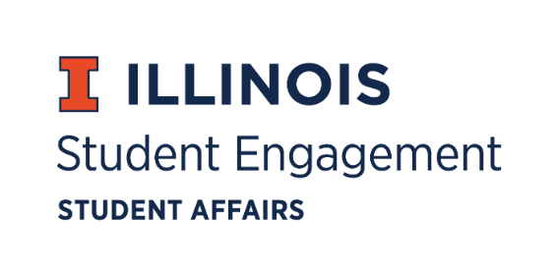
Student Organization
Resource Fee
SORF Meeting
Tuesday, April 5, 2022 at 5:00PM
Microsoft Teams
Roll Call:
Present:
- Michael Isaacson, Chairperson
- Alex Wang, Vice-Chairperson
- Umar Ahmed, SORF Treasurer
- Jimmy Song, Undergraduate Board Member
- Inaaz Mirza, Undergraduate Board Member
- Ashley Winters, Undergraduate Board Member
- Nico Perez, Undergraduate Board Member
- Damian Chavez, Undergraduate Board Member
- Brian Farber, Faculty/Staff Board Member
- Stephanie Cardoza-Cruz, Faculty/Staff Board Member
- Nick Fink, SORF Advisor (non-voting member)
- Christina Fraser, SORF Secretary (non-voting member)
- Sheri Idris, SORF Financial Secretary (non-voting member)
Absent:

Old Business:

Application Review for Tabled Spring Programs & Projects Funding Period 3, 3/10/22- 5/31/2022:
App Number | Funding Type | RSO Name | Amount Requested | Amount Allocated | Vote
149080 | Large Scale Programming | Korean Student Association, Korean Liberal Arts Student Organization, and Korean Illini Football Association | $11,200.69 | $11,200.69 | 7-0-2

- App No. 145126- Korean Student Association
- Description: K-Week is a large-scale event held by Korean Student Association with KLASO and KIFA. The event starts on the 15th of April and spans through the next week. The events include: the playing of traditional Korean games, singing and dancing to Korean music, eating traditional Korean foods, a talent show at Foellinger auditorium, an athletic competition, and a career seminar day. These events are hosted with the focus on providing exposure to Korean culture for all, having fun and inclusive events, and celebrating the 100th year anniversary since the first Korean student at UIUC. Expenses are for the following: rental space fees (Foellinger & Campus Instructional Facility), advertisements, consumable supplies, equipment rentals, food/beverages, rental space fees (outlet use at Anniversary Plaza). Program meets the required criteria for funding.
- Funding type: Large Scale Programming
- Amount Requested: $11,200.69
- Amount Allocated: $11,200.69
- Meeting notes: Brian Farber motions to table application (requesting via email proof of contract for facility space rental agreement). Nico Perez seconds. Vote of 9-0-0.
- Update: Received contractual service agreement from RSO. Vote of 7-0-2 to fund application at standard.

New Business:

Contingency Funding Application Review:

App Number | Funding Type | RSO Name | Amount Requested | Amount Allocated | Vote
150814 | Contingency | Gamma Phi Omega International Sorority, Inc. | $1,000.00 | $1,000.00 | 8-0-1

- App No. 150814- Gamma Phi Omega International Sorority, Inc.
  - Description: RSO originally had an application approved for an event, a spoken word performance by Danyeli Rodriguez Del Orbe (application 137725). The performer had emergency throat surgery that prevented her from being able to perform and the RSO must find another performer. SORF cannot grant an alternative speaker for the original application because no alternate performers were listed in the application. RSO has found an alternative performer (Roxana Pardo Garcia – La Roxay) and would like partial funding for the same event (Xingona; A Journey of Community, Family, and Healing) with a different performer based on the reasonably unforeseen circumstances.
  - Funding type: Contingency
  - Amount Requested: $1,000.00
  - Amount Allocated: $1,000.00
  - Meeting notes: Vote of 8-0-1 to fund at standard.

