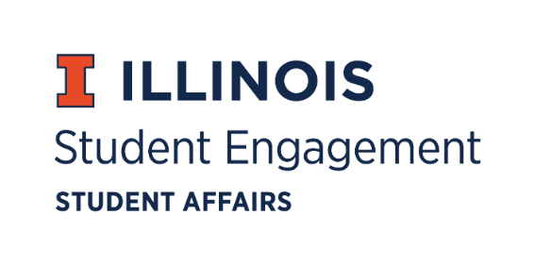
Student Organization
Resource Fee
SORF Meeting
Thursday, March 3, 2022 at 5:00PM
Microsoft Teams
Call to Order:
Michael Isaacson calls meeting to order at 5:07pm.

Roll Call:
Present:
- Michael Isaacson, Chairperson
- Jimmy Song, Undergraduate Board Member (Proxy for Inaaz Mirza)
- Ashley Winters, Undergraduate Board Member (Proxy for Nico Perez)
- Damian Chavez, Undergraduate Board Member
- Brian Farber, Faculty/Staff Board Member
- Stephanie Cardoza-Cruz, Faculty/Staff Board Member (Proxy for Umar Ahmed)
- Nick Fink, SORF Advisor (non-voting member)
- Christina Fraser, SORF Secretary (non-voting member)
Absent:
• Alex Wang, Vice-Chairperson
• Umar Ahmed, SORF Treasurer
• Nico Perez, Undergraduate Board Member
- Inaaz Mirza, Undergraduate Board Member
- Sheri Idris, SORF Financial Secretary (non-voting member)

Approval of 02/24/22 Minutes:
Michael Isaacson approves by unanimous consent.
Approval of 03/03/22 Agenda:
Michael Isaacson approves by unanimous consent.

Old Business:

Application Review for Tabled Programs & Projects Funding Period 2, 3/10/22- 5/31/2022:
App Number | Funding Type | RSO Name | Amount Requested | Amount Allocated | Vote
136189 | Programs | Arab Student Association | $4,655.00 | $4,655.00 | 7-0-0

- App No. 136189- Arab Student Association
  - Description: The SJP/ASA fashion show will serve to showcase the diversity and multiculturalism integrated within the Arab social fabric and tradition. SORF board confirmed that payment will not be made to a member of the RSO via email with RSO executive board.
  - Funding type: Programs
  - Amount Requested: $4,655.00
  - Amount Allocated: $4,655.00
  - Update: Jimmy Song motions to approve application at standard. Brian Farber seconds. Vote of 7-0-0.

New Business:

Contingency Applications:
App Number | Funding Type | RSO Name | Amount Requested | Amount Allocated | Vote
141609 | Contingency | Penny Dreadful Players | $405.00 | $0.00 | 8-0-0
141996 | Contingency | Hip-Hop Collective at UIUC | $987.75 | $0.00 | 8-0-0
143364 | Contingency | IlliniFurs | $1,000.00 | $0.00 | 7-0-0

- App No. 141609- Penny Dreadful Players
  - Description: Funding for performance venue and set materials, costume pieces, and props. SORF board voted to deny the application as the RSO was out of compliance with the Office of Student Engagement.
  - Funding type: Contingency
  - Amount requested: $405.00
  - Amount allocated: $0.00
  - Meeting notes: Brian Farber motions to zero fund application. Damian Chavez seconds. Vote of 8-0-0.

- App No. 141996- Hip-Hop Collective at UIUC
  - Description: The Lock In Event, is an expansion on a project we started last semester, with the essential goal being: to create a hip-hop oriented music album, within the confines of writing and recording all material within 12 hours. SORF voted to deny the application because it appeared to be due to poor planning rather than a reasonably unforeseen occurrence.
  - Funding type: Contingency
  - Amount requested: $987.75
  - Amount allocated: $0.00
  - Meeting notes: Jimmy Song motions to zero fund application. Brian Farber seconds. Vote of 8-0-0.

- App No. 143364- IlliniFurs
  - Description: Now that things are more certain, we are planning on attending an additional convention, FurSquared, this April 14-17. SORF board voted to deny the application because it did not view this as reasonably unforeseen (based on the ability of RSO’s to apply for funding and complete the SORF forfeiture if the event does not occur).
  - Funding type: Contingency
  - Amount requested: $1,000.00
  - Amount allocated: $0.00
  - Meeting notes: Jimmy Song motions to zero fund application. Damian Chavez seconds. Vote of 7-0-0.

Large Scale Programming Applications:

App Number | Funding Type | RSO Name | Amount Requested | Amount Allocated | Vote
140579 | Large Scale Programming | The Punch Line | $50,000.00 | $49,400.00 | 7-0-0

- App No. 140579- The Punch Line
  - Description: The Punch Line and UIUC YDSA are seeking to hold a large-scale music festival at the University of Illinois at Urbana-Champaign titled "TKO 2022". One line item was zero funded (of the amount $600.00) because SORF cannot fund insurance fees.
  - Funding type: Large scale programming
  - Amount requested: $50,000.00
  - Amount allocated: $49,400.00
  - Meeting notes: Jimmy Song motions to approve application at standard. Stephanie Cardoza-Cruz seconds. Vote of 7-0-0.

For the good of the order:

Adjournment:
Meeting adjourned at 5:46pm.

