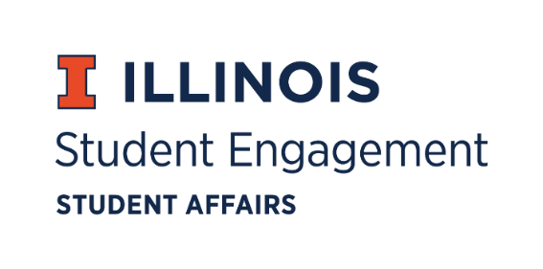
Student Organization
Resource Fee
SORF Meeting
Thursday, October 21, 2021, at 5:00
Virtual
Call to Order:
Meeting Called to Order at 5:00 pm

Roll Call
Present
Michael Isaacson, Chairperson
Alex Wang, Vice Chairperson
Umar Ahmed, Treasurer
Sheri Idris, Financial Secretary
Jimmy Song, Undergraduate Board Member
Maha Hussain, Undergraduate Board Member
Ashley Winters, Undergraduate Board Member
Inaaz Mirza, Undergraduate Board Member
Nico Perez, Undergraduate Board Member
Brian Farber, Faculty/ Staff Board Member
Stephanie Cardoza-Cruz, Faculty/ Staff Board Member

Nick Fink, Program Advisor, Coordinator of Student Engagement

Absent:
Amir Jafari, Graduate Board Member
Christina Fraser, Secretary

Michael motions to vote by unanimous consent to approve the current week’s meeting minutes.
Michael motions to vote by unanimous consent to approve last week’s meeting minutes.

New Business:
App No. | Organization | Requested Amount | Allocated Amount | Vote
116058 | College Republicans at UIUC | $5000.00 | $0.00 | 7-0-1

- Background Notes on App No. 116058
  - Submitted on August 30, 2021, 7:52PM by Michael Bijos
  - Programs Funding - Fall 2021, Period 2
  - Description of program given by club: College Republicans at UIUC intend to bring an in-person Guest Speaker to campus this year. Working with the Student Engagement Team to ensure adequate COVID-19 precautions, we're partnering with Young America's Foundation (YAF) to bring a Guest Speaker to campus for a lecture and Q&A at Foellinger Auditorium. Former Vice President Michael Pence is the speaker we're in discussions with at this time.
  - Notes from the meeting on September 23, 2021:
    - App No. 116058
      - The Honorarium costs are not specified, and seems more like a gift rather than an established contract,
      - The SORF Board does not allow for honorarium’s as they are not specifically listed in the current 2021-22 standards.
      - Motion to zero-fund the application:
        - 7-0-1
- Meeting Notes from October 21st
  - The SORF Board reviewed the initial application and all supporting documentation provided from the College Republican’s RSO
  - SORF Board came to the consensus that due to the large amount of time it takes to receive confirmation of the event and aligning that with the SORF time frame the addition of allowing alternative speakers/performers should be accepted by SORF.
  - Brian Farber made a motion to grant the appeal, Alex Wang seconds.
    - The appeal passes by a vote of 5-0-3.
  - SORF Board had discussions about adding a section to the application allowing for approved alternative speakers/performers for applications of similar nature and amending the standards
  - With the implication that this will be changed in the future, because College Republicans did not have access to this technology it would be unfair to deny their application
  - The nature of the speakers remained the same based on the proposals submitted to both speakers (Pence and Sessions)
    - Alex Wang makes a motion to approve at standard, Brian Farber seconds. By a vote of 6-0-3 the application is approved at standard.
  - The SORF Board did not feel adequately prepared to approve the exact wording of the amendment to the standards (including an acceptable range of alternative speakers if the nature of the speaker/event remains the same)
    - Umar Ahmad makes a motion to table the amendment to a later date, Jimmy Song seconds. The motion passes by a vote of 9-0-0.
For the good of the order:
Adjournment:
Meeting adjourned at 6:19 pm.

