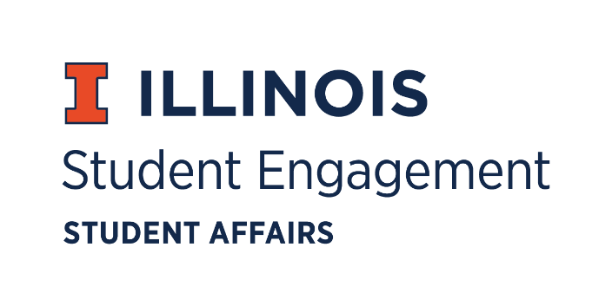
Student Organization
Resource Fee
Exec Retreat
Tuesday January 19, 2021 at 2:00PM
Microsoft Teams
Call to Order

Roll Call
Present
Jimmy Song, Chairperson
Nico Perez, Treasurer
Jasmine Cuasay, Secretary
Nick Fink, Program Advisor, Coordinator of Student Engagement

Absent
Omer Mirza, Vice Chairperson

Note:
Reflection
Reception from campus
Not a lot of applications for spring 1, closes Jan 24th
Revisit permanent equipment
Email application reminders and socials
Work on social media presence
SORF meeting on 4/29
Transition to new board
Finances
Board apparel
Ask board for preferences
For marketing, banner/ signage when in persons resume
Reconciling
Admin > Configure > Forms > SORF Reconciliation form
Can also view RSO funds in Involved@Illinois

For the good of the order
Adjournment

