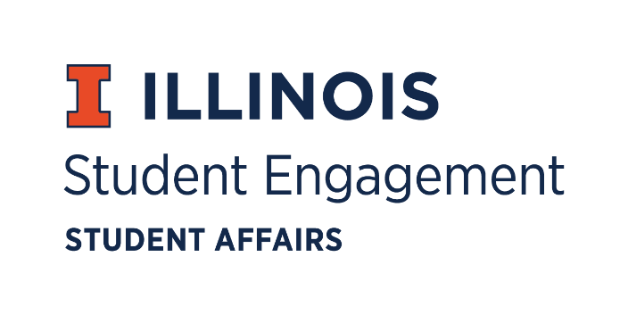
Student Organization
Resource Fee
SORF Meeting
Thursday November 19, 2020 at 5:00PM
Zoom
Call to Order
5:01PM

Roll Call
Present
Jimmy Song, Chairperson
Omer Mirza, Vice Chairperson
Nico Perez, Treasurer
Bilal Shahid, Undergraduate Board Member
Alex Wang, Undergraduate Board Member
Michael Isaacson, Undergraduate Board Member
Zachary Becker, Undergraduate Board Member
Hannah Valdiviejas, Graduate Board Member
Brian Farber, Faculty/ Staff Board Member
Marile Quintana, Faculty/ Staff Board Member
Jasmine Cuasay, Secretary
Nick Fink, Program Advisor, Coordinator of Student Engagement

Absent
Adam Peterson, Undergraduate Board Member

Note:
Approval of minutes
SORF Allocation Meeting 11/12/20
Alex Wang makes a motion to approve the minutes, Nico Perez seconds
Jimmy Song makes a motion for unanimous consent, no objections
Minutes approved
Approval of agenda
SORF Allocation Meeting 11/19/20
Alex Wang makes a motion to approve the minutes, Nico Perez seconds
Jimmy Song makes a motion for unanimous consent, no objections
Minutes approved

Old Business
Application Review
App No | Funding Type | Reviewer | RSO Name | Funding Requested | Amount Funded | Vote
95532 | Services Funding | Zach | The National Society of Pershing Rifles | $5,600.00 | $2,318.00 | 9-0-0
95675 | Programs Funding | Hannah | Iranian Cultural Association | $700.00 | $700.00 | 9-0-0
95667 | Services Funding | Bilal | Phi Alpha Delta - Pre-Law Undergraduate Chapter | $999.99 | $0.00 | 8-0-1
Tabled Applications
- App No. 95532- The National Society of Pershing Rifles
  - Description: equipment/uniforms and expenses necessary for the attendance of the Pershing Rifle national convention
  - Reviewer’s notes: Asked for additional details on their application. Sent what they gave me to Michael and Jimmy
  - 11/12/20 Meeting notes: Uniform t shirts described as membership apparel, SORF does not fund membership apparel, rifle is permanent equipment, Pershing Rifles Rank Shields classified under uniform, meals are not a part of service funding, fuel is a part of transportation, tabled to learn about distinction between uniform and membership apparel, and hotel expense
  - 11/19/20 Meeting notes: SORF does not fund meal expenses. Organization provided Jimmy with hotel-only expense and amount was adjusted accordingly.
  - Alex Wang makes a motion to adjust line item 2 under budget section “National Convention” to $268.00, Nico Perez seconds
  - Vote of 9-0-0, adjustment approved for line item 2
  - Zachary Becker makes a motion to fund at standard, Alex Wang seconds
  - Vote of 9-0-0, funding is approved at standard
- App No. 95675- Iranian Cultural Association
  - Description: Cooking competition
  - Reviewer’s notes: No proof of line-item costs
  - 11/12/20 Meeting notes: Advisor challenges criteria of programs funding, tabled to allow for org to provide context on how this program would occur and submit documentation of items
  - 11/19/20 Meeting notes: updated email correspondence with further budget information
  - Nico Perez makes a motion to fund at standard, Alex Wang seconds
  - Vote of 9-0-0, funding is approved at standard
- App No. 95667- Phi Alpha Delta - Pre-Law Undergraduate Chapter
  - Description:
  - Reviewer’s notes: General fees, need more information on what initiation materials need funding
  - Chairperson’s notes: Told Bilal to email asking what specific expenses are in general fees
  - 11/12/20 Meeting notes: tabled due to board not providing 48 hours for response on initial email.
  - 11/19/20 Meeting notes: no correspondence from RSO
  - Nico Perez makes a motion to zero fund, Alex Wang seconds
  - Vote of 8-0-1, zero fund approved
For the good of the order
Adjournment
5:18PM

