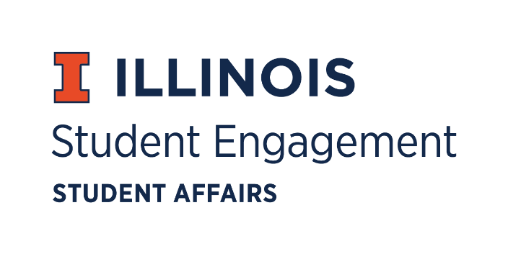
Student Organization
Resource Fee
SORF Meeting
Thursday October 22, 2020 at 5:00PM
Microsoft Teams
Call to Order
5:05PM

Roll Call
Present
Jimmy Song, Chairperson
Nico Perez, Treasurer
Adam Peterson, Undergraduate Board Member
Bilal Shahid, Undergraduate Board Member
Alex Wang, Undergraduate Board Member
Michael Isaacson, Undergraduate Board Member
Zachary Becker, Undergraduate Board Member
Hannah Valdiviejas, Graduate Board Member
Jasmine Cuasay, Secretary
Marile Quintana, Faculty/ Staff Board Member
Nick Fink, Program Advisor, Coordinator of Student Engagement

Absent
Omer Mirza, Vice Chairperson
Alex Suñé, Associate Director, Student Success & Engagement

Board Training

Officer hours

Adjournment
6:07PM

