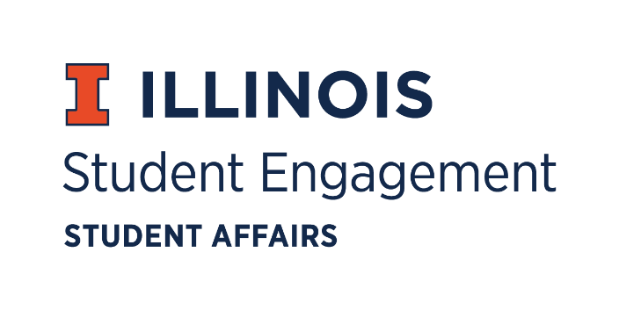
Student Organization
Resource Fee

SORF Funding Standards Review Meeting Pt 2
Thursday August 27, 2020 at 5:00PM
Microsoft Teams
Call to Order

5:06PM

Roll Call
Present
Jimmy Song, Chairperson
Omer Mirza, Vice Chairperson
Nico Perez, Treasurer
Alex Wang, Undergraduate Board Member
Adam Peterson, Undergraduate Board Member
Michael Isaacson, Undergraduate Board Member
Zachary Becker, Undergraduate Board Member
Bilal Shahid, Undergraduate Board Member
Hannah Valdiviejas, Graduate Board Member
Jasmine Cuasay, Secretary
Nick Fink, Interim Program Advisor, Coordinator of Student Engagement
Alex Suñé, Interim Program Advisor Associate Director, Student Success & Engagement
New Business

- Question funding events where students are being charged twice
  - Cases where organizations are already receiving money from SORF

- Charity, philanthropy
  - Historically not funded by SORF

- Should SORF fund 100% of orgs/ programs?
  - Close to 100%- having organizations think more carefully about what they want to buy
  - Surplus
    - Consider posterity, long term
  - Incentivizes organizations to open up more programming

- Equal Access/ Opportunity
  - Prevents org- benefitting equipment/ clothing/ utilities
  - Language may be too restrictive
  - Hold off vote
  - Don’t put ourselves in a position for lawsuits

- Table 1
  - Exhaustive or thematic?
  - Permanent equipment
    - Language for the type of equipment
  - How is SORF supporting non restrictive vs. restrictive membership?
    - Providing equal funding?
  - Inclusivity
    - Beneficial to have partiality towards organizations that are open
  - Explore co- programming

- Maximum allocation
  - As SORF, shouldn’t focus on operations
    - Reduction of maximum allocation?
    - Good cushioning for organizations
    - Keep combined operations and programming events at $12,000

- Equipment guidelines
  - Ways of interpreting the language
    - Ex. printing paper vs drawing paper
  - Over $1,000 is university property
    - Tracking?
      - Internally in RSOs or SORF, others?
  - Money laundering

- Table 2
  - Travel guidelines
  - How to fund charter buses

- Prohibited Types of Requests
  - Started funding in 2017
    - Pressure to expel funding towards organizations
    - New mentality on consolidating back to SORF mission statement
  - Is it right for SORF to pay for a student’s membership fees to participate in the org?

- COVID 19- addendum
- Framework is to help RSOs understand what they can still do
- $500 gift
  - Boost to organizations considering circumstances
  - Would be automatic
    - Engagement with finance center, good marketing, push for RSOs to register and become active, using surplus
  - Can students abuse the gift?
  - Application process?

- Vote next meeting on standards

Adjournment

6:56PM

