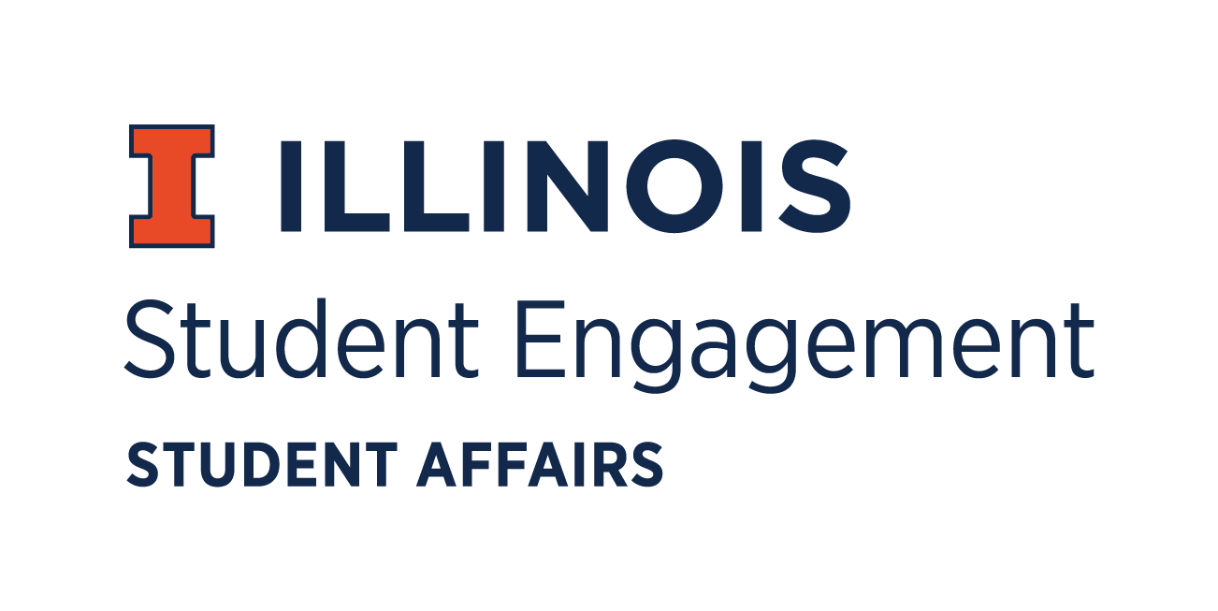
Student Organization
Resource Fee
SORF Bylaw and Standards Review
Thursday, April 30, 2020 at 5:00 p.m.
Microsoft Teams
Call Meeting to Order
5:15 pm
Roll Call
Present
- Adam Peterson, Chairperson
- Marc Sleiman, Vice Chairperson
- Nicolas Perez, Treasurer
- DeBrias Lake, Undergraduate Board Member
- Jimmy Song, Undergraduate Board Member
- Lamar West, Undergraduate Board Member
- David Hanley, Graduate Board Member
- Nick Fink, Staff Board Member
- Terry Free, Staff Board Member
- Michaela Foreman, Secretary
- Alex Suñé, Interim Program Advisor
Associate Director, Student Success & Engagement
Absent
- Ali Mirza, Undergraduate Board Member
- John Brown, Staff Board Member

Unfinished Business
- Approval of New SORF Standards
Approved 7-0-0
New Business
- Approval of New SORF Bylaws
Approved 7-0-0
For the Good of the Order
Adjournment
6:19 pm

