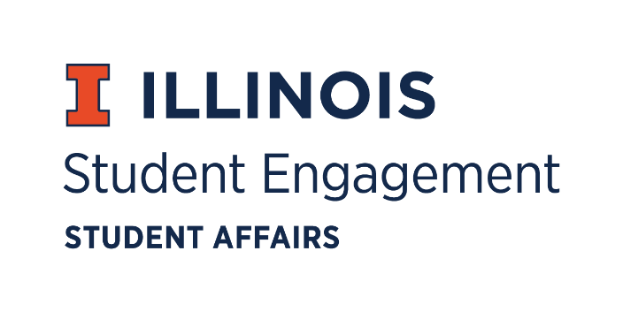
Student Organization
Resource Fee
Transition Board Meeting
Thursday, May 7, 2020 at 5:00 p.m.
Microsoft Teams
Call Meeting to Order
5:05 pm
Roll Call
Present
- Jimmy Song, Chairperson (outgoing)
- Omer Mirza, Vice Chairperson
- Nico Perez, Treasurer
- TBD, Secretary
- Zachary Becker, Undergraduate Board Member
- Michael Isaacson, Undergraduate Board Member
- Adam Peterson, Undergraduate Board Member
- Bilal Shahid, Undergraduate Board Member
- Alex Wang, Undergraduate Board Member
- VACANT, Graduate Board Member
- VACANT, Graduate Board Member
- John Brown, Staff Board Member
- Nick Fink, Staff Board Member
- VACANT, Staff Board Member
- Alex Suñé, Interim Program Advisor
Associate Director, Student Success & Engagement
Absent
Announcements
Officer Elections
- Jimmy Song, Chairperson
Approved 9-0-0
- Omer Mirza, Vice Chairperson
Approved 9-0-0
- Nicolas Perez, Treasurer
Approved 9-0-0
Funding Standards
- Contingency Committee - Tabled to the beginning of 2020-2021 Semester
Approved 9-0-0
Advisor Report
For the Good of the Order
Adjournment
6:15 pm

